## **Install Confluent Kafka on Dataproc Cluster**

Install Confluent Kafka using below commands:

|  |
| --- |
| cd ~  wget -qO - https://packages.confluent.io/deb/5.2/archive.key | sudo apt-key add -  sudo add-apt-repository "deb [arch=amd64] https://packages.confluent.io/deb/5.2 stable main"  sudo apt-get update && sudo apt-get install confluent-platform-2.12 |

Give 777 permission to /var/lib/zookeeper

|  |
| --- |
| sudo chmod -R 777 /var/lib/zookeeper |

### **Start the confluent service**

Let’s start the confluent Services:

|  |
| --- |
| confluent start |

You can check service status with this command:

|  |
| --- |
| confluent status |

You can check the logs with this command:

|  |
| --- |
| confluent logs {service name} |

**Note:** If you are facing below error

Trying to access the KSQL CLI facing below error:

Remote server at [http://localhost:8088](http://localhost:8088/) does not appear to be a valid KSQL

server. Please ensure that the URL provided is for an active KSQL server.

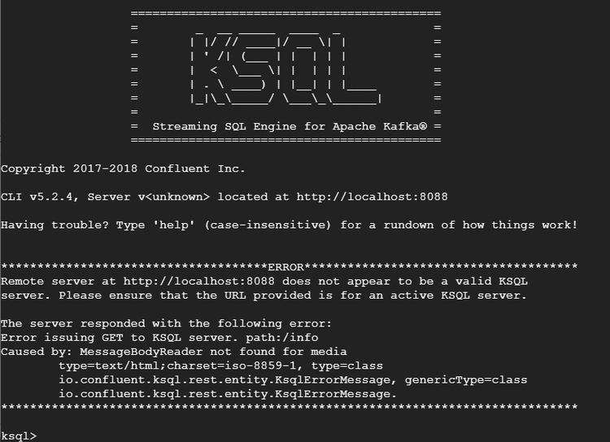

#### 

Edit ksql-server.properties

|  |
| --- |
| sudo vi /etc/ksql/ksql-server.properties |

Change listener 8088 to 8089

listeners=[http://localhost:8089](http://localhost:8089/)

Save the file and restart Confluent service

|  |
| --- |
| confluent stop  confluent start |

Open KSQL prompt (Ignore error related to /etc unknown host):

|  |
| --- |
| ksql http://localhost:8089 |

